
Life on Earth | Year 6 | Unit 4
Assessment task — Investigating mouldy bread: Teaching notes
Assessment purpose: To develop an investigable question and design an investigation into simple cause-and-effect relationships including identifying variables to be changed and measured and potential safety risks. To collect, organise and interpret data to identify environmental factors that contribute to mould growth in bread and explain how scientific knowledge helps to solve problems.
Assessment summary
Assessment type: Experimental investigation
There are three parts to assessment task:
Part A: Plan an investigation about mould growth
Part B: Observe, record and analyse results
Assessment resources:
- Assessment task and Guide to making judgments
- Model response
- Materials and equipment list
- Investigating mouldy bread: Student resource (Template)
Conditions
- Investigations may be conducted in groups of three or less
- Assessment questions are answered independently
- Undertaken in class time
- Held under test conditions
- To be completed in four sessions
Safety
- Refer to the Health and Safety (http://education.qld.gov.au/health/safety/index.html) policy pertaining to schools
- Consult the Curriculum Activity Risk Management Guidelines (http://education.qld.gov.au/curriculum/carmg/index.html) and ensure that a risk assessment has been completed.

IMPORTANT SAFETY INFORMATION
- The mould grown in this investigation is a health hazard and is to remain inside a resealable sandwich bag that has been securely taped to ensure the bag cannot be easily opened.
- At the completion of the investigation, all bread is to be left in these bags and disposed of safely by a responsible adult.
- Reinforce safety when using plastic knives. Students should not walk around with the plastic knife and plastic knives should not be handed from student to student. A responsible adult should carefully supervise the use of plastic knives and they should be collected as soon as they are no longer needed.
- Students need to wear appropriate protective equipment, such as closed-in footwear.
- Be aware of additional hazards such as furniture, equipment, food and water spills, and ensure students move appropriately around the classroom and outside areas. Wipe up any spills immediately.
- Emphasise the importance of students’ personal hygiene, e.g. washing hands after all investigations.
Detailed advice
Prior to Part A
Teacher:
- Access and become familiar with the assessment resources.
- Make sure students are aware of the safety considerations in this investigation. Reinforce the need to seal bags securely and that they must not be reopened.
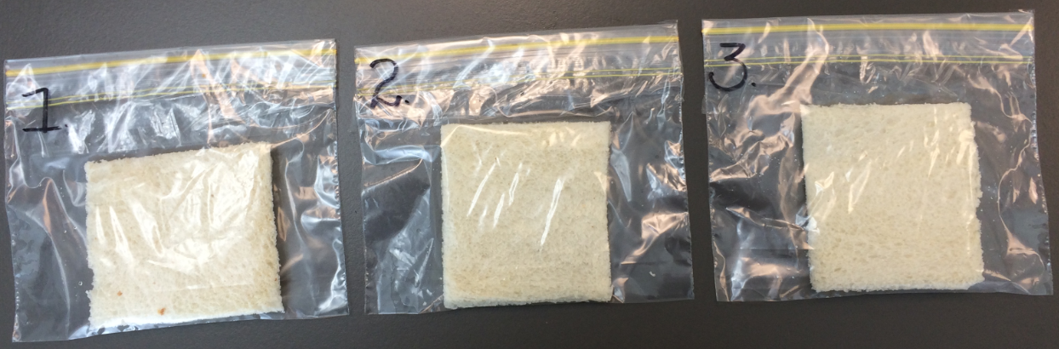
- Check to see if any students have allergies to mould or bread.
Prepare the required resources, materials and equipment for students.
- You may wish to print/draw some 10 x 10 cm grids (Appendix A) on OHT transparencies or other plastic sheet/sleeve to overlay on the top of the bagged bread. This will provide an accurate way for students to observe the location of the mould to transfer to their recording grid. Encourage students to brainstorm other ways such as using a ruler, estimating, taking a photo and using software tools to insert a grid and explore ways of drawing around the mould.
- Bread from a bakery usually has fewer preservatives and will grow mould faster than shop-bought bread.
Hint: Ways to increase growth of mould:
- Purchase bread a few days before the investigation.
- A spray bottle filled with water may be used for a light spray of water on each piece of bread. For a fair test, ensure each piece gets the same amount of water.
- Expose bread slices to the open air in the classroom for a few hours to allow mould spores to collect on the surface.
Part A: Plan an investigation about mould growth
In Part A students will plan and conduct an investigation of a variable that affects the amount of mould growth in bread.
Teacher:
- Organise the students into groups of three (depending on class size).
- Provide students with their materials and equipment.
- Instruct students to discuss the task of planning and conducting an investigation of a variable that affects the amount of mould growth with the group.
- Direct students to complete questions 1–7. Some questions need to be completed individually and some as a group.
- Check each group’s investigation method to ensure practicality and safety.

- Direct students to conduct the investigation.
- Monitor the mould growth and don’t proceed with the data gathering phase of the assessment until there is sufficient data to collect. The bread samples will need approximately one week to grow sufficient mould before students begin Part B of the investigation.
Students:
- Access and become familiar with the assessment resources.
- Plan and conduct the investigation.
Part B: Observe, record and analyse results
Students have been allocated two lessons to complete Part B of the investigation.
Teacher:
- Direct students to complete questions 9–13 individually.
Note: Ensure students are aware a side-by-side column graph is used when there are two or more attributes for each variable.
Students:
- Record investigation observations and complete questions 9–13.

